

Al-Rafidain Journal of Computer Sciences and Mathematics (RJCSM)

www.csmj.uomosul.edu.iq

Paper Title* (use style: paper title)

First name Last name, First name Last name and First name Last name

Enter Author Affiliation ¹ , Enter Author Affiliation ², …
Email: author@example.com¹, author@example².

Article information |  | Abstract
Article history:  Received  Revised  Accepted  Published |  | This electronic document serves as a live template, providing a predefined structure for your paper, including styles for the title, text, headings, and more. Authors are encouraged to follow the formatting guidelines strictly to ensure consistency and readability across submissions. *CRITICAL: Do not include symbols, special characters, footnotes, or mathematical expressions in the paper title or abstract, as these elements may cause formatting issues or rejection during the publication process. Additionally, no citation of papers should be included in the abstract. Adhering to these instructions help streamline the review and publishing workflow, ensuring your paper is accurately represented.
Keywords:
Computer
Mathematics

Correspondence:
Author Name
Email: author1@round.com

DOI: 10.33899/csmj.2025.XXXXXX.XXXX, ©Authors, 2025, College of Computer Science and Mathematics, University of Mosul, Iraq.
This is an open access article under the CC BY 4.0 license (http://creativecommons.org/licenses/by/4.0).

- Introduction
This template, modified in MS Word 2007 and saved as a “Word 97-2003 Document” for the PC, provides authors with most of the formatting specifications needed for preparing electronic versions of their papers. All standard paper components have been specified for three reasons: (1) ease of use when formatting individual papers, (2) automatic compliance to electronic requirements that facilitate the concurrent or later production of electronic products, and (3) conformity of style throughout a conference proceedings. Margins, column widths, line spacing, and type styles are built-in; examples of the type styles are provided throughout this document and are identified in italic type, within parentheses, following the example. Some components, such as multi-leveled equations, graphics, and tables are not prescribed, although the various table text styles are provided. The formatter will need to create these components, incorporating the applicable criteria that follow.

- Ease of use
First, confirm that you have the correct template for your paper size. This template has been tailored for output on the A4 paper size. If you are using US letter-sized paper, please close this file and download the Microsoft Word, Letter file. Figure 1.
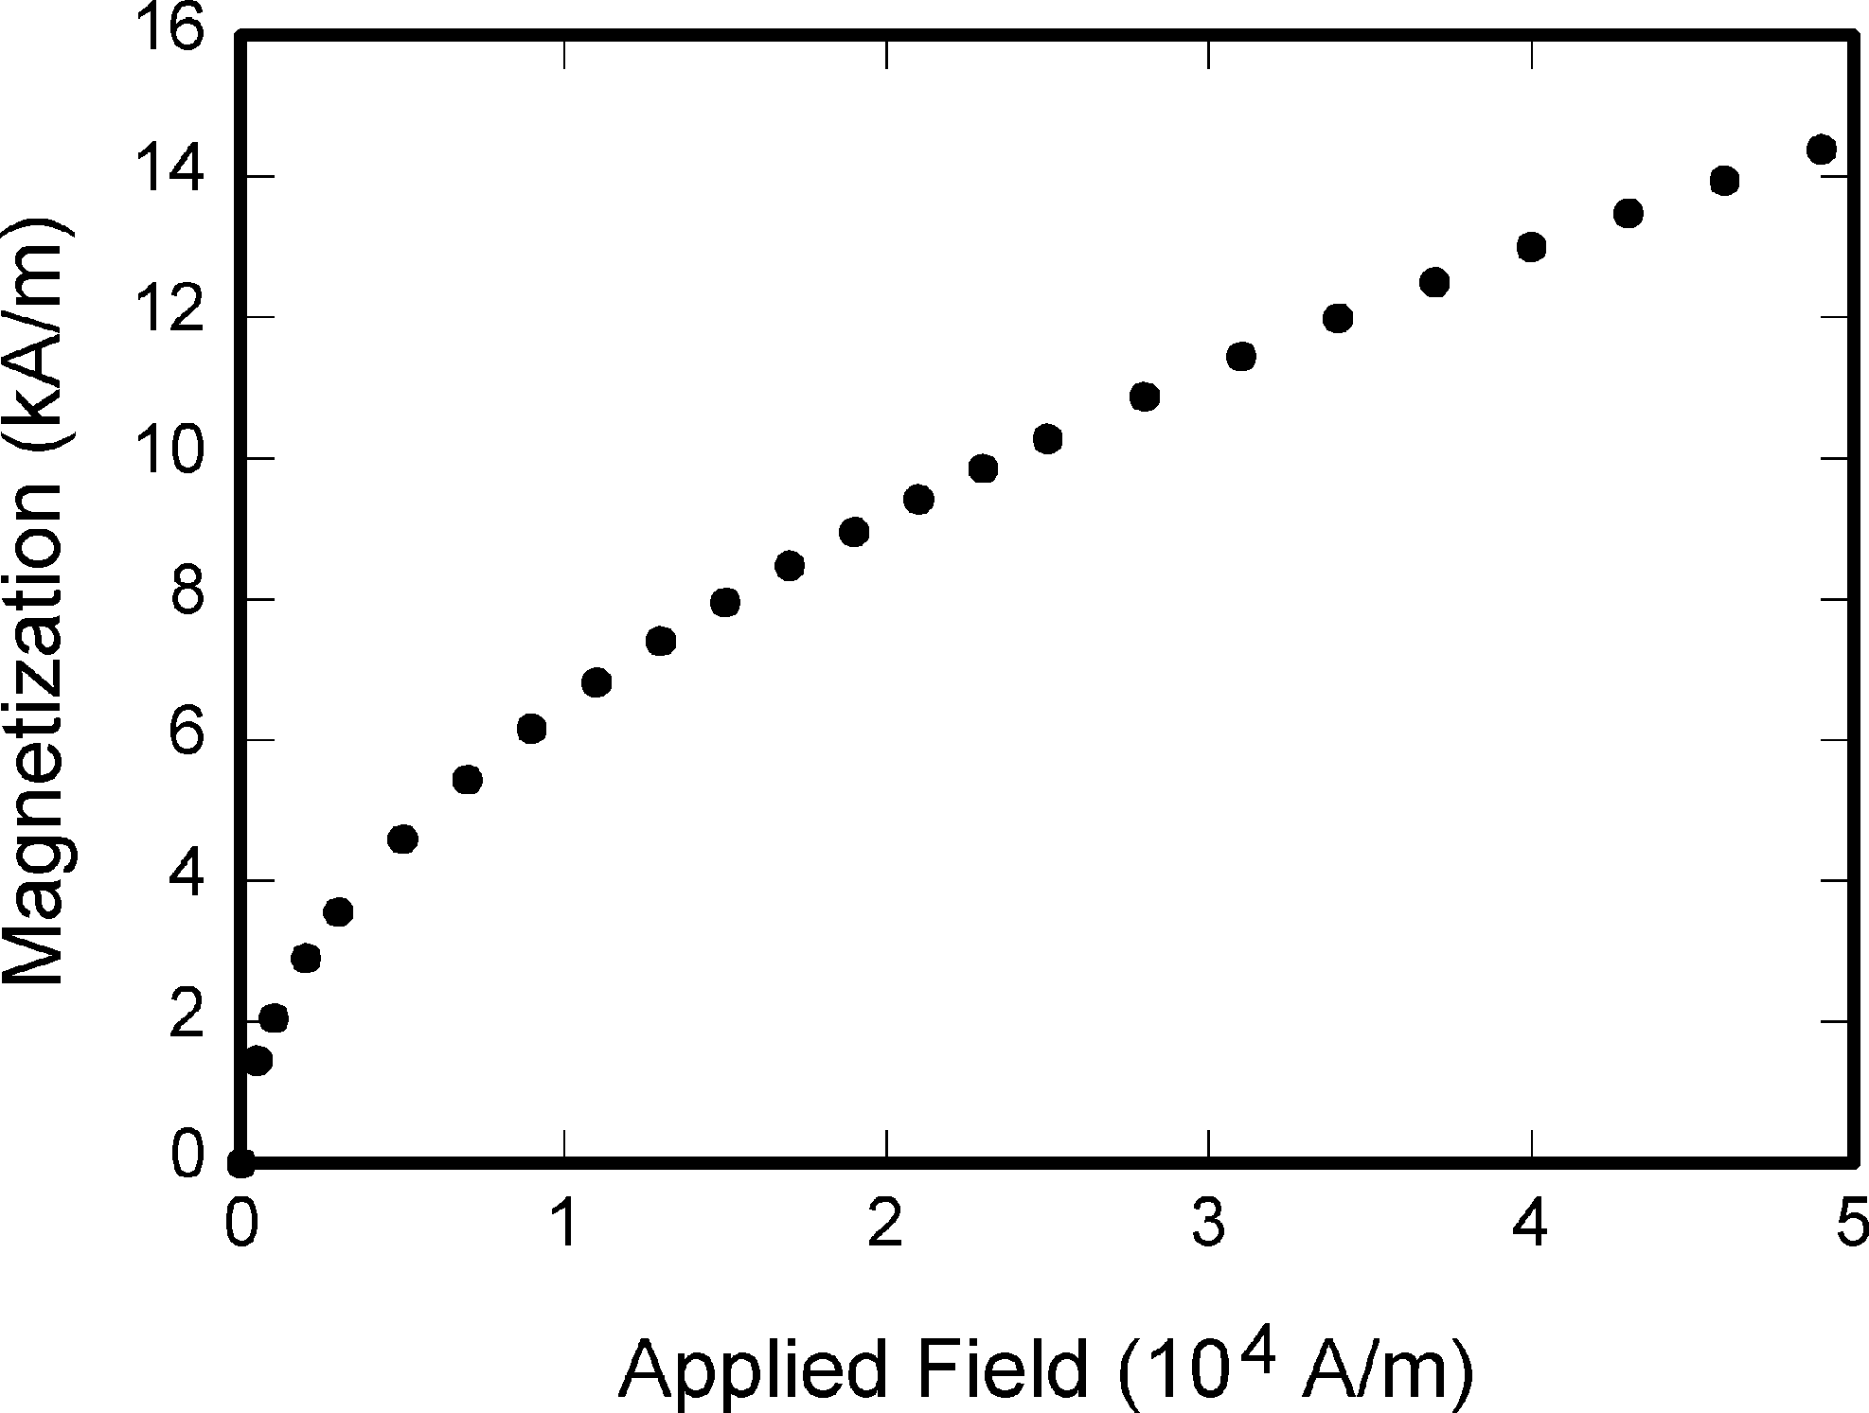
Figure 1. The word “Figure” should be written in full. A period follows the figure number, then a single space. Captions should include a brief explanation of the figure’s significance.

2.2 Style palette
Styles can be applied using the style palette available within the template. To activate it the press Ctrl+Shift+s. Apply the style as required based on the content and context. (Please don’t highlight your text in yellow.). Table 1.

Table I. Table type styles.

Table Head | Table Column Head
Table Head | Table column subhead | Subhead | Subhead
copy | More table copyª

Conclusion
Using of NaCl in high doses can cause significant changes in blood profile, blood cell counting, minerals, enzymes, and antioxidant with pathological changes that lead to 100% mortalities in Cyprinus carpio, in addition the concertation of 100 grams of NaCl in 1000 L of water for 5 minutes will be sufficient to disinfected fish from many pathogens including fungal infection.

Acknowledgement
The authors would express they're thanks to college of xxxxx, University of Mosul to support this report.

Conflict of interest
None.

References
The template will number citations consecutively within brackets [1]. The sentence punctuation follows the bracket [2]. Refer simply to the reference number, as in [3]—do not use “Ref. [3]” or “reference [3]” except at the beginning of a sentence: “Reference [3] was the first ...” Number footnotes separately in superscripts. Place the actual footnote at the bottom of the column in which it was cited. Do not put footnotes in the abstract or reference list. Use letters for table footnotes. Unless there are six authors or more give all authors’ names; do not use “et al.”. Papers that have not been published, even if they have been submitted for publication, should be cited as “unpublished” [4]. Papers that have been accepted for publication should be cited as “in press” [5]. Capitalize only the first word in a paper title, except for proper nouns and element symbols. For papers published in translation journals, please give the English citation first, followed by the original foreign-language citation [6].
- A. Sharma, L. Chen, and M. Patel, “Fourier-Bessel integrals in high-dimensional data analysis and neural signal processing,” IEEE Trans. Pattern Anal. Mach. Intell., vol. 47, no. 3, pp. 485–498, Mar. 2025.
- M. Z. Ahmed, Advanced Electromagnetic Theory for AI Applications, 4th ed., vol. 2. Cambridge, MA: MIT Press, 2025, pp. 102–115.
- T. Nguyen and R. Dasgupta, “Sparse representations and anisotropic filtering in computer vision,” in Advances in Computational Mathematics, vol. 9, Y. Zhao and H. Lin, Eds. New York, NY: Springer, 2025, pp. 233–264.
- J. R. Owens, “Novel cryptographic schemes for post-quantum systems,” unpublished manuscript, University of California, Berkeley, 2025.
- K. Torres, “Deep learning architectures for high-accuracy medical image segmentation,” J. Comput. Intell. Syst., in press, 2025.

